Lab 4 Connecting Windows 7 to a Domain Network
The Windows 7 Professional and Ultimate editions are designed to join a domain quickly and more securely. The following steps will join your computer to the Contoso domain.
Establishing the Network Connection
- Start Windows 7 and log on as the Administrator.
- From the start menu click on Control Panel
- Click on Network and Sharing center
- In the network and sharing center click on Change adapter settings
- Right- click on Local Area Connections and select Properties
- In the Local Area Connection Properties dialog box, select Internet Protocol Version 4 (TCP/IPv4) and then click Properties.

Question 1: What other version of TCP/IP is listed?

- In the Internet Protocol (TCP/IP) Properties dialog box, select Use the following IP address
- In the IP Address text box, type 10.10.10.2xx.
- In the Subnet Mask text box, type 255.255.0.0.
- In the Default Gateway text box, type 10.10.10.30.
- In the Preferred DNS Server text box, type 10.10.10.200
- In the Alternate DNS Server text box, type 10.10.10.30
- Click OK.
- In the Local Area Connection Properties dialog box, click Close.
- Close the Network Connections window.

Connecting to the Contoso Domain
- Open System by clicking the Start button , right-clicking Computer, and then clicking Properties.
- Under Computer name, domain, and workgroup settings, click Change settings. If you're prompted for an administrator password or confirmation, type the password or provide confirmation.
- Click the Computer Name tab, and then click Change.
- Under Member of, click Domain and type Contoso and click OK. The following dialog box will open
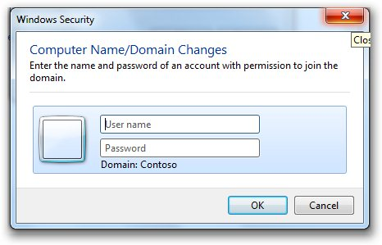
- For the User name type Administrator and the password none.
- Click OK
- When you are welcomed to the Contoso Doman click OK
- When you are prompted to restart your computer Click OK
- In the System Properties dialog box click close.
- In the next window click Restart now
Question 2: After Windows 7 restarts how has the log in changed?
- Log on as Local Administrator
- Log off
- When prompted press Ctrl + Alt + Delete
- Click on Other Users
- Click on the link How to log on to other domains.
Question 3: How do you log on to the local computer?
- Log on to the local computer as Student7xx using the password you created.
- Log off and log on as the Administrator with the correct password.
- Right- click on the desk top, hover over New and select Text document.
- Name the text document Administrator test.
- Log off and log on as COMPUTER7xx\administrator using the password you created.
Question 4: Did you find the text document when you logged in as Computer7xx\administrator and what does the tell you about the local administrative account log in?
Question 5: Can you log in as other local users without including the COMUTER7xx\ prefix?
- Log off and log on as studentxx with the password of P@ssw0rd.
Question 6: What does the above log in tell you about the location of Studentxx account?
- Close all open windows.
- Shut down Windows 7.

